Persona

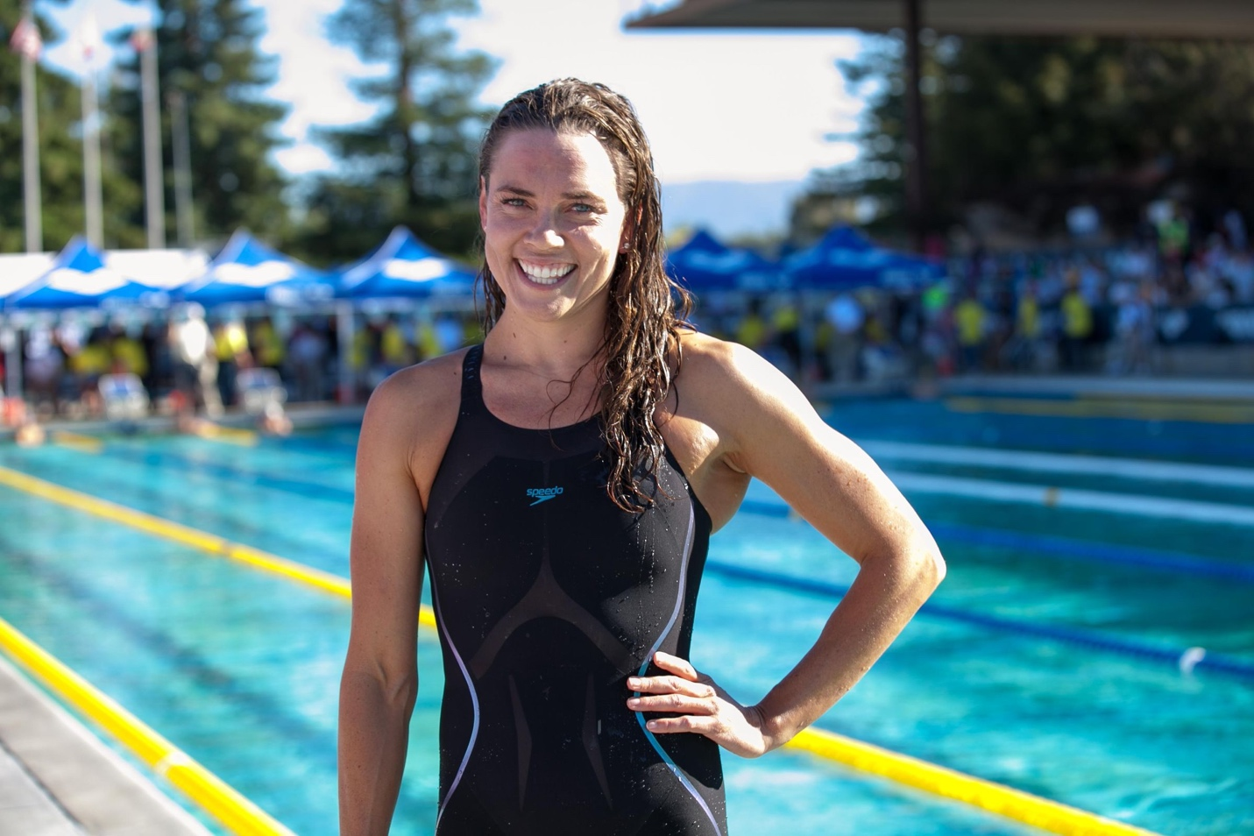

Nicole is an assistant coach for the University of Maryland varsity swimming team. This season she would like to help her team reach bigger heights the year. In order to better asses her teams strengths and weaknesses Nicole wishes she had a more analytical tool for her team. A tool which enables her to study her team performance in a more quantitative sense. Nicole would like to compare certain statistics of different members of her team while also interpreting her player’s qualitative opinions on their own performances. She needs a tool that is relatively lightweight and easy to use, something which the entire team can efficiently take advantage of.